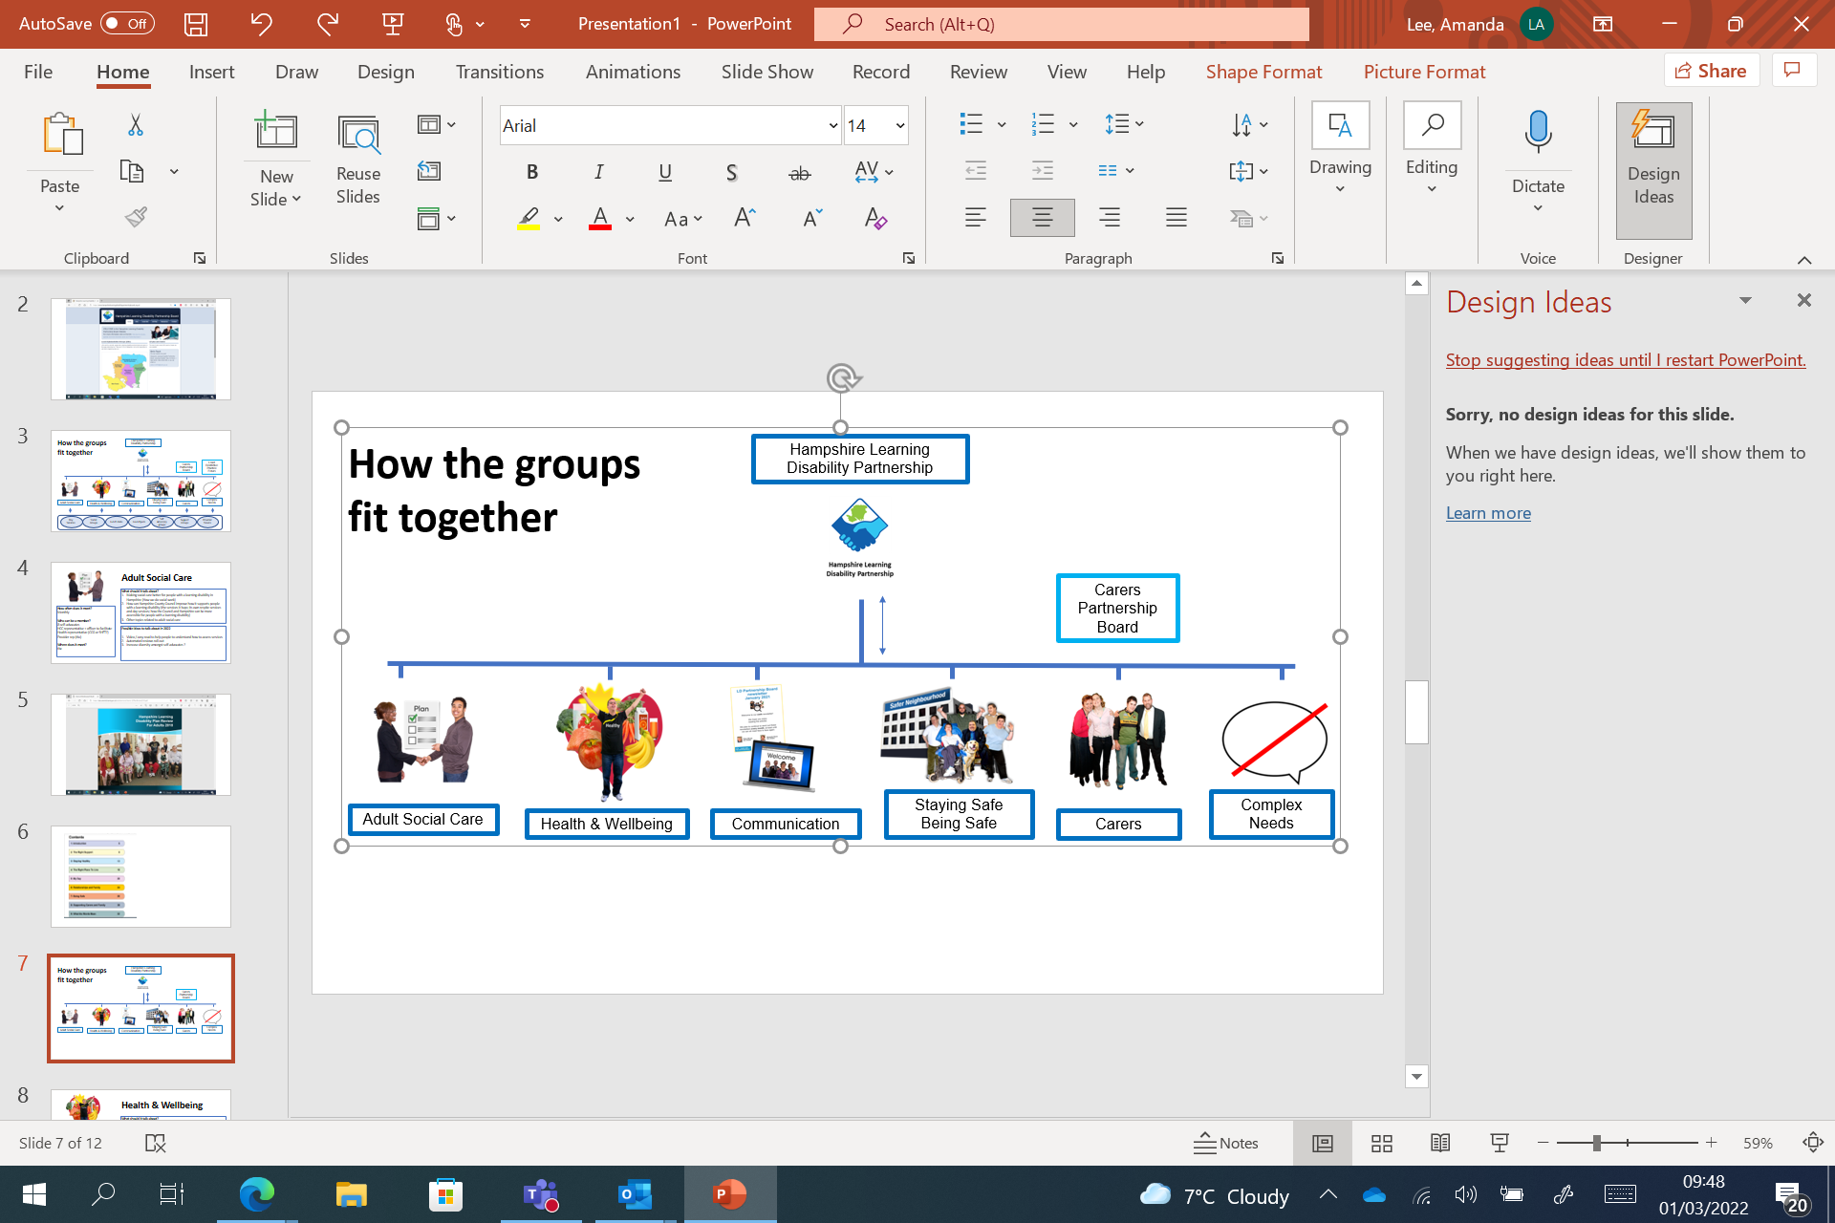**Adult Social Care – The Right Support  
Monday 10 October, 11:00 – 12:30**

|  |  |  |
| --- | --- | --- |
| **Time** | **What we will talk about** | |
| Time 11:00 | Meeting Welcome | **Welcome and introductions** |
| Time 11:05 | Papers | **You Said We Did** |
| Time 11:15 | Calculate Money | **Savings Plan update:**  Stuart Outterside presenting |
| Time 11:30 | Question3 | **Savings Plan - Questions** |
| Time 11:45 | Coffee break2 | **Break** |
| Time 12:00 | Any Other Business | **Anything else?** |
| Time 12:30 | Closed 1 | **End of the meeting** Our next meeting will be:  Monday 7 November, 11:00 – 12:30 |