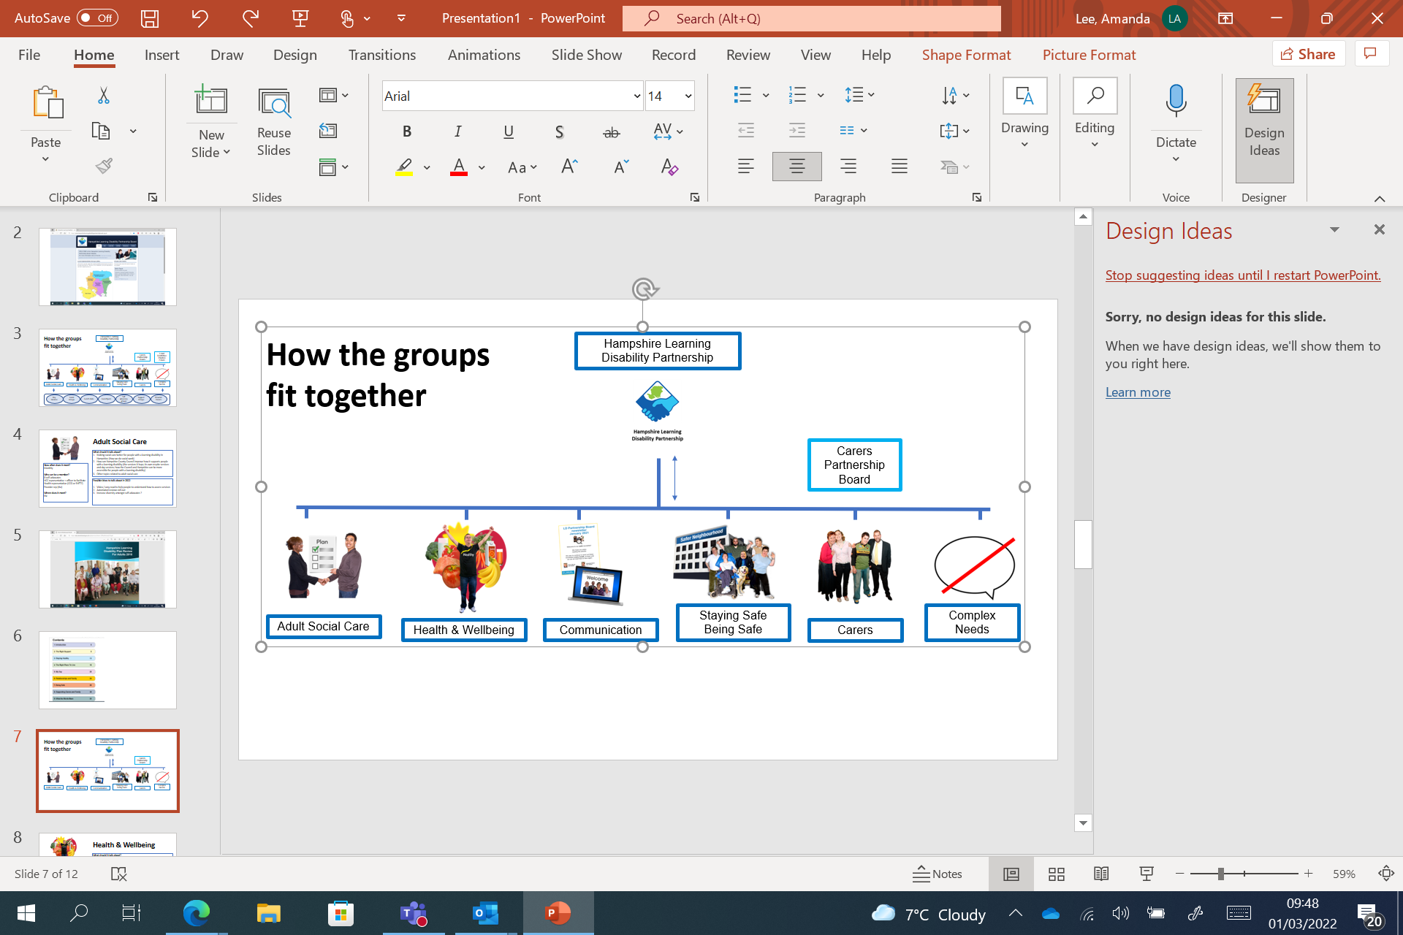**Adult Social Care – The Right Support  
Monday 12 September July, 11:00 – 12:30**

|  |  |  |
| --- | --- | --- |
| **Time** | **What we will talk about** | |
| Time 11:00 | Meeting Welcome | **Welcome and introductions** |
| Time 11:05 | Papers | **You Said We Did** |
| Time 11:15 | Group Discussion 1 | **Discussion Topics:**   * What do you want to talk   about? |
| Time 11:50 | Questionnaire 2 | **Meetings and Feedback:**   * How will you get feedback? * What would help? |
| Time 12:20 | Any Other Business | **Anything else?** |
| Time 12:30 | Closed 1 | **End of the meeting** Our next meeting will be:  Monday 10 October, 11:00 – 12:30 |