Adult Social Care – The Right Support
Monday 4 July, 11:00 – 12:30

Time | What we will talk about
 |  | Welcome and introductions
 | 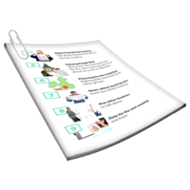 | You Said We Did
 | 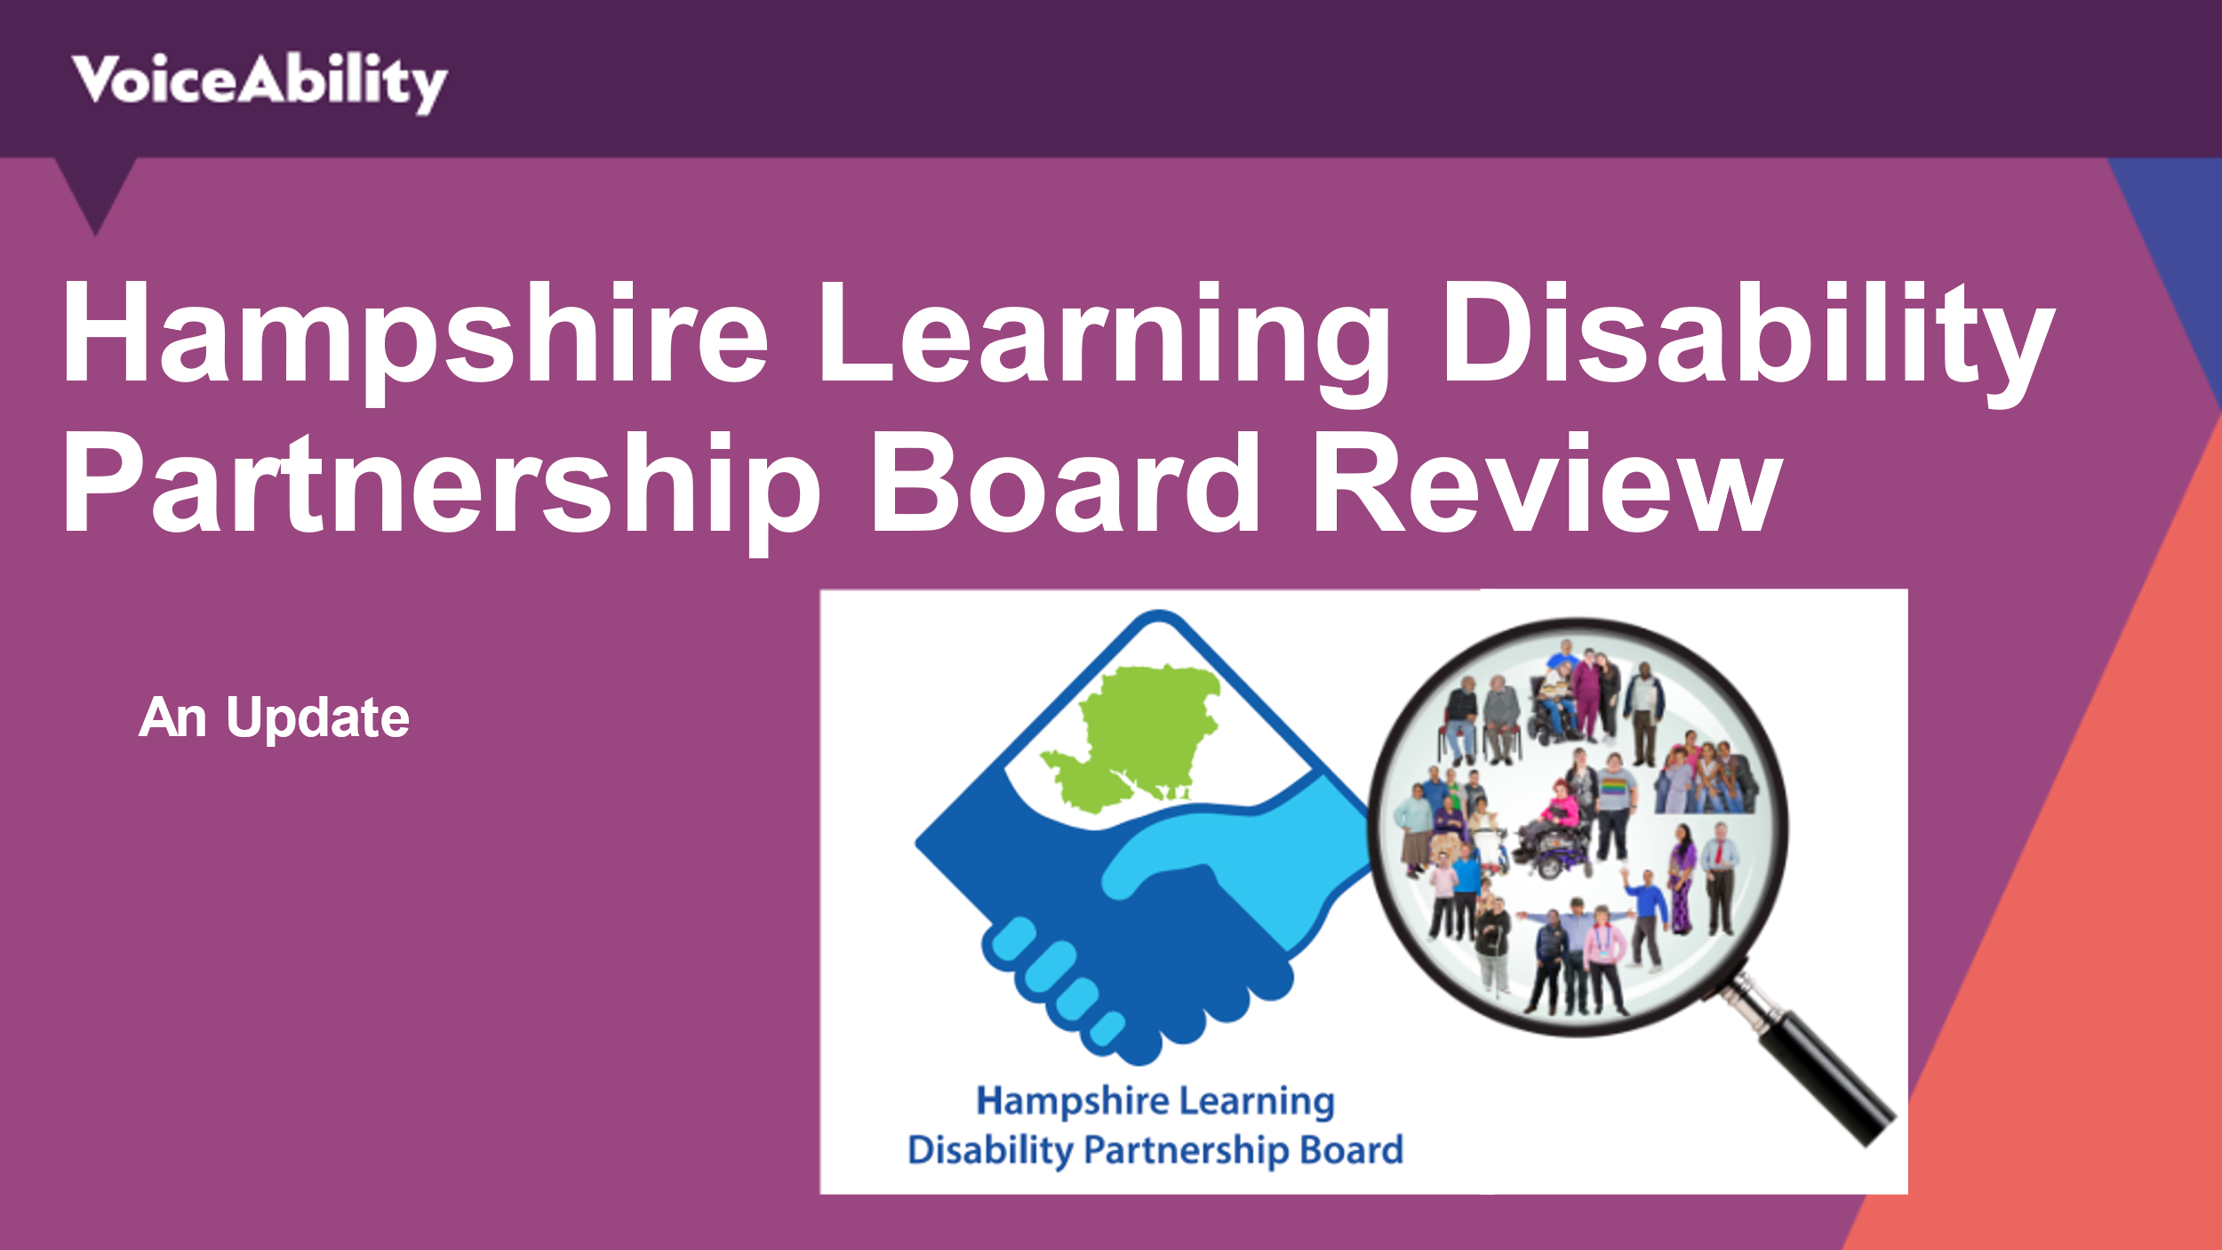 | Presentation: Hampshire Learning Disability Partnership - Review  - Presented by Self-Advocates  - Time for questions
Discussion Topic: Rise in cost
of living

- How has this affected you?

- What concerns do you have?

- What would help?

- Impact on others around you?

 |  | Anything else?
End of the meeting
Our next meeting will be:
Monday 12 September, 11:00 – 12:30

