HAMPSHIRE LEARNING DISABILITY PARTNERSHIP MEETING

Wednesday 28 June 2023
10.00am to 12.30pm
Fair Oak Room
Wells Place Eastleigh SO50 5LJ

10:00 –  10:10 |  | Welcome and rules  - Welcome  - Rules of online meeting  - Apologies  - Who we all are?  - Guests present  - Approval of the last minutes & report  on actions
10:10 –  10:45 |  | Update from working groups
10:45 –  11:05 |  | Break (20 mins)

11:05 –  11:20 |  | Update on Budget Consultation
11:20 -  11:30 | 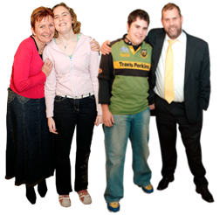 | Update from Carers Group
11:30 -  11:40 |  | Update from Complex Needs Group
11:40 –  12:00 |  | Break (20 mins)
12:00 –  12:25 |  | Discussion:  Forward Plan for 2023
12:25 –  12:30 |  | Anything Else?

