Communications

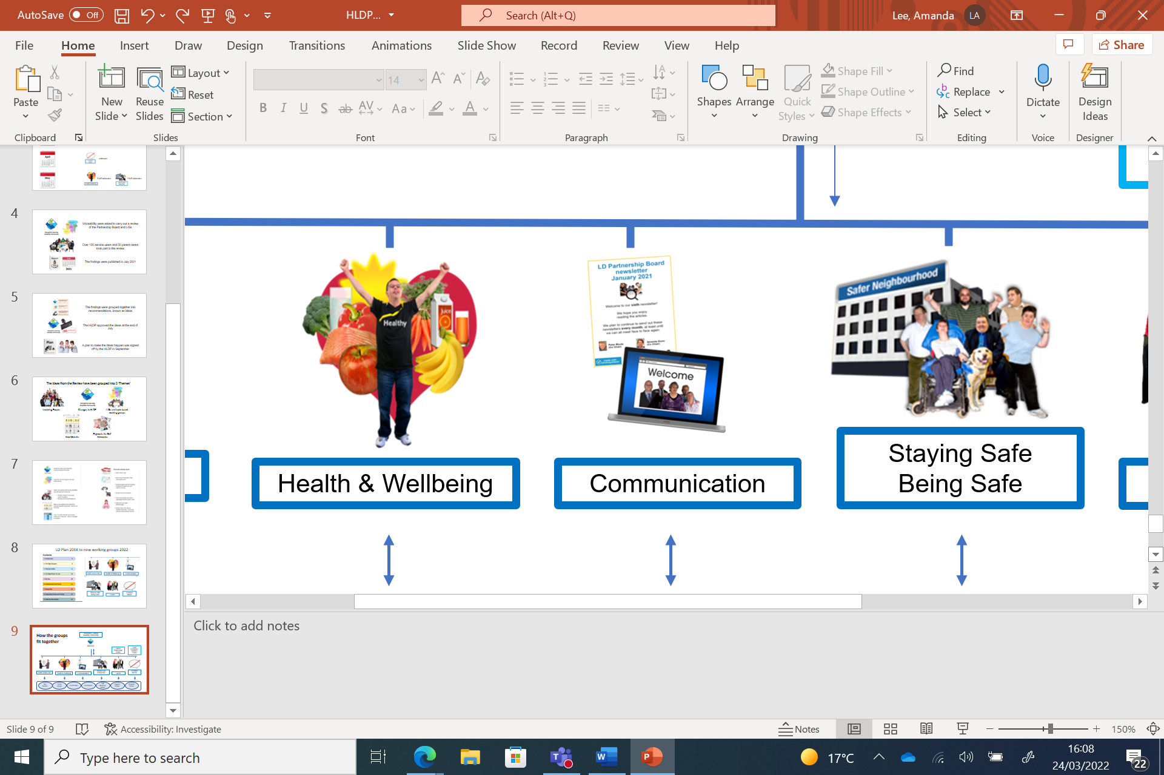

Working Group

Meeting Dates

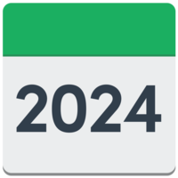

**Thursday**

|  |  |
| --- | --- |
| 18 January  Date Jan 18 Time 02:00 | Microsoft Teams meeting  **Join on your computer or mobile app** |
| 15 February  Date Feb 15 Time 02:00  1 | Microsoft Teams meeting  **Join on your computer or mobile app** |
| 21 March  Date Mar 21 Time 02:00 | Microsoft Teams meeting  **Join on your computer or mobile app** |
| 18 April  Chairperson  Date Apr 18 Time 02:00 | Chair: Marcia  Join Teams  On Computer or Phone |
| 16 May  Chairperson  Date May 16 Time 02:00 | Chair: Jake  Join Teams  On Computer or Phone |
| 20 June  Chairperson  Date Jun 20 Time 02:00 | Chair: Arun  Join Teams  On Computer or Phone |
| 18 July  Chairperson  Date Jul 18 Time 02:00 | Chair: Katie  Join Teams  On Computer or Phone |
| 15 August | Summer Break  No meeting |
| 19 September  Chairperson  Date Sep 19 Time 02:00 | Chair: Richard  Join Teams  On Computer or Phone |
| 17 October  Chairperson  Date Oct 17 Time 02:00 | Chair: James  Join Teams  On Computer or Phone |
| 21 November  Chairperson  Date Nov 21 Time 02:00 | Chair: Tanya  Join Teams  On Computer or Phone |
| 19 December  Chairperson  Date Dec 19 Time 02:00 | Chair: Jake  Join Teams  On Computer or Phone |