Hampshire Learning Disability Partnership
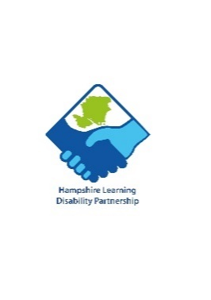
Complex Needs Group
Meeting Notes from 28th November 2023

Background to the group
There are wonderful self-advocates in place at the Partnership meetings, but a need had been identified to represent individuals who are not able to advocate for themselves. People who knew and understood them intimately were needed to speak up on their behalf, raise issues, share experiences, share information and report to the Learning Disability Partnership.
Partnership meeting: Presentation to be prepared in easy-read format, avoiding jargon. Guidance will be shared with speakers.
It was felt that it was important not duplicate work done in the Carers Group. Agendas should be shared and cross-referenced so that parent carers can choose which meetings to attend to stay informed without repetition.
Membership
Family carers: It was agreed not to limit the number of as not all can attend each meeting. Agreed to promote in Direct Payments newsletter, send information to day services and other organisations for inclusion in newsletters (All)
Health: ICB representatives, a GP (AL, AMC, SE)
Hampshire County Council: AMC agreed to make attending the meetings a priority
Other providers: Suggestions Request Nursing Care Agency, Hamberley Care, Liaise Loddon, previous providers who had expressed an interest or have relevant expertise (All)
Topics
Health: (this was a big area) including
- Access to screening services
- Lack of reasonable adjustments, support and accessible facilities
- Annual Health Checks and access to GP
- Dental care
- Medication – labelling discrepancies, Pharmacy services, restriction on organisations’ ability to administer
- End of life and Do Not Resuscitate orders
- Continuing Healthcare (CHC) - Clare Smith future speaker? (AL)
Respite: Lack of access to suitable services, closure of facilities. Hamberley Care: Opening a neuro-rehab facility in the local area (no one present aware of the organisation) Future speaker? (AC)
Support staff: Recruitment, training, values. Future speaker from Request Nursing Care Agency to be invited (AC). New Care Certificate (AL)
Trauma Informed Care and Least Restrictive Practice (Link to Studio 3 free webinars https://www.studio3.org/free-webinars NAC Wellbeing webinar: https://www.youtube.com/watch?v=qfgJY3ANi9I&t=556s
Inclusion and accessibility: access to leisure opportunities, meaningful services etc.
Second Transition: project update
Future Meetings
(Before 3.15pm to avoid clashes with transport duties, not Mondays, Tuesdays ok but not the last Tuesday of the month.)
Agreed 1.30pm to 3pm, Tuesdays (avoiding last Tuesday of the month), bi-monthly.

Next meeting: 23rd January 2024, 1.30pm

