Hampshire Learning Disability Partnership
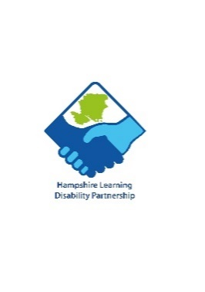

Complex Needs Group

Meeting Notes from 16th July 2024
Present: 9
Apologies: 7

Everyone introduced themselves and the minutes of the last meeting were agreed.
Points raised in the meeting:
- Gateway club access card has lots of opportunities
- reapplying for blue badge on the Internet is really difficult
- Sail-ability is good they have a pay as you go scheme £5 a session, it is a risk assessed activity so would need to be supported Sailability
Tracy came from the NHS Hampshire and Isle of Wight (previously ICB) to talk about her role as Transformation Manager, Learning Disability and Autism Team.
Tracy's work initially was to increase the uptake of annual health checks to a 75% target from 60% there is still more work to be done for the age group 14 to 17 years old.
Another focus is creating LD friendly practises in Hampshire with actions and risk assessments monitored to lead to an accreditation. Sensory and communication boxes have been given to 95% of the practices in Hampshire, information can be shared about this (Action AL) some have also gone to acute wards.
Some work has been done in explaining reasonable adjustments within Primary Care and the national drive for digital flags to be added and shared for health colleagues on health records.
Issues raised:
- Keeping a constipation chart is important, digital records led to the loss of charts
- Teeth brushing – there is a waiting list for cleaning under anaesthetic. Good dental hygiene very important for health
- Example given of use of suppositories in residential care by staff, at home probiotics used to keep regular movements with no issues
- Constipation and dentistry issues noted by Tracy
- Discussion of Carers support, RETT syndrome association, Café Dome THE CAFE PROJECT CHARITY No - 1150811 - Home in Basingstoke
- Link for support groups could be added to website, bring to next meeting (All)
- Challenging behaviour Foundation have a form that can be filled in which can be updated for health needs, hospital passports are always different
- Respect forms being used instead of DNRs aim by NHS to put these in sooner rather than have difficult conversations at stressful times – check they are up to date with GPs (?)
- PBS4 Home - PBS4 is good, good team with Jonathan Beebee
- Pay at £12.86 is not enough to attract staff– main recruitment by parent carers through indeed, also discussed PA finder Hampshire PA finder
- Need quality and consistent staff – some agencies are £15 an hour and agency £31 a hour
- £12.86 decided as it relates to band 4 on NHS pay scale.

5 November at 1.30pm
AC thanked all for attending and next meeting will be 17 September on Teams

