Communications

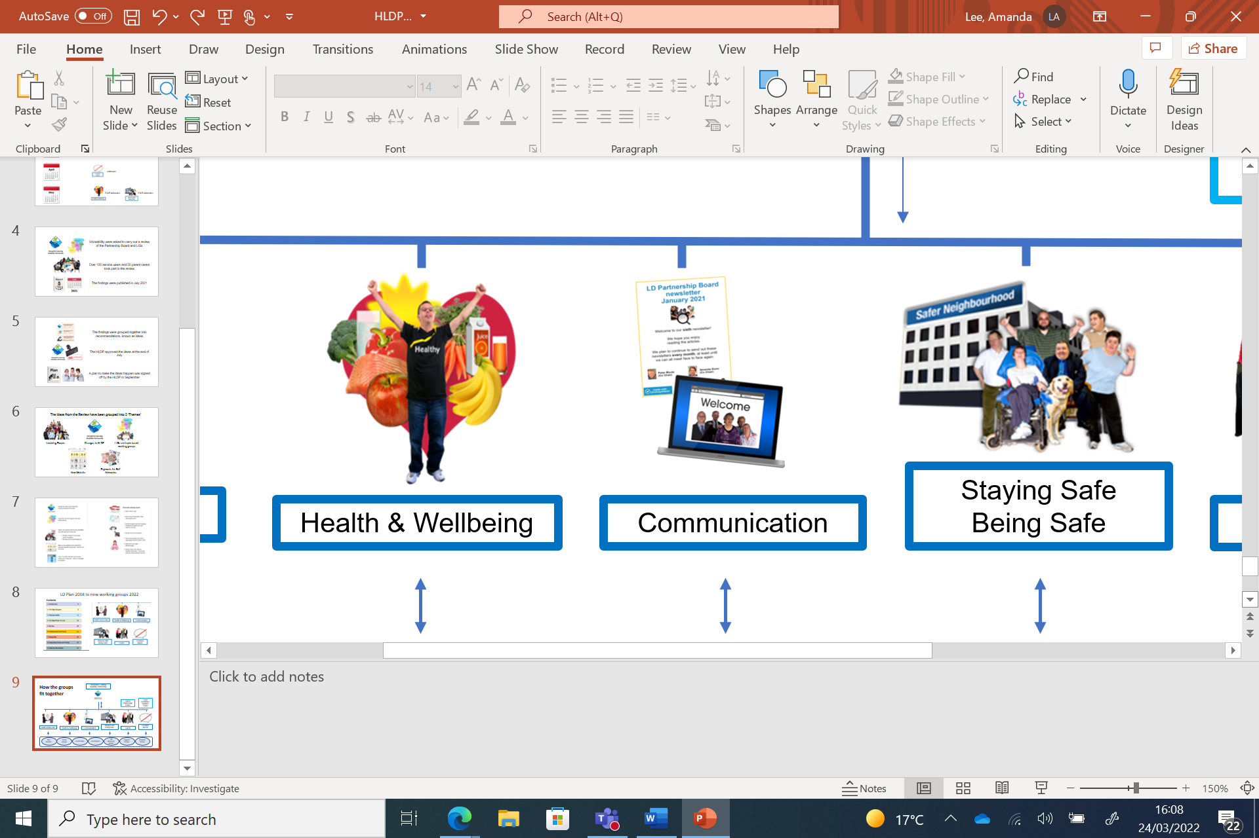

Working Group

Meeting Dates

**Thursday**

|  |  |
| --- | --- |
| 16 January  Time 02:00 | Microsoft Teams meeting  **Join on your computer or mobile app** |
| 20 February  Time 02:00 | Microsoft Teams meeting  **Join on your computer or mobile app** |
| 20 March  Time 02:00 | Microsoft Teams meeting  **Join on your computer or mobile app** |
| 17 April  Time 02:00 | Join Teams  On Computer or Phone |
| 15 May  Time 02:00 | Join Teams  On Computer or Phone |
| 19 June  Time 02:00 | Join Teams  On Computer or Phone |
| 17 July  Time 02:00 | Join Teams  On Computer or Phone |
| 21 August | Summer Break  No meeting |
| 18 September  Time 02:00 | Join Teams  On Computer or Phone |
| 16 October  Time 02:00 | Join Teams  On Computer or Phone |
| 20 November  Time 02:00 | Join Teams  On Computer or Phone |
| 18 December  Time 02:00 | Join Teams  On Computer or Phone |