Meeting address:
HCC, Elizabeth II Court building, Sussex St, Winchester SO23 8BH

Car parking: Closest parking is Tower Street or the buses from all of Winchester Park and Ride car parks stop near Elizabeth II Court. Use either of the two Westgate stops, labelled Pa and Pb - https://www.winchester.gov.uk/parking/park-and-ride/
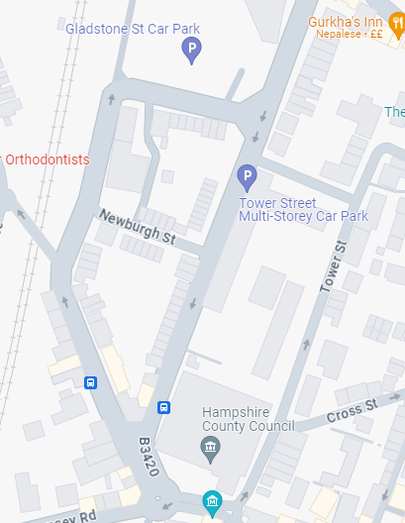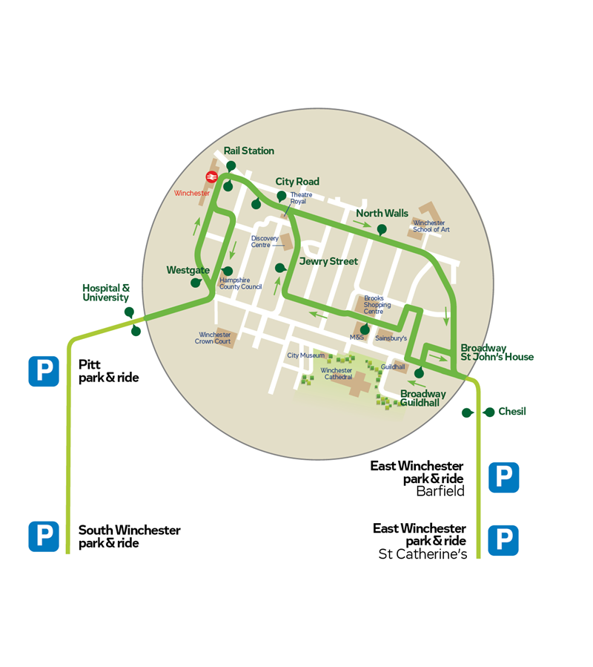
Train: Winchester station
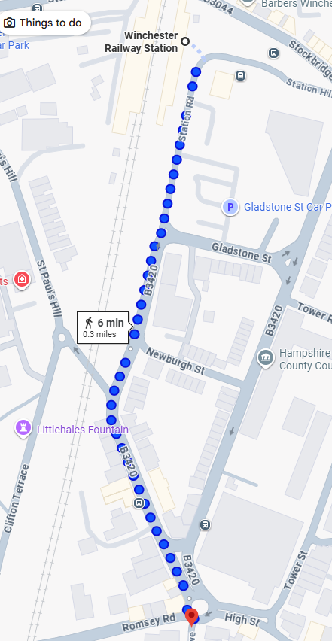
Winchester station is about a 10-minute walk to HCC’s EII building.
Turn right out of the station, then turn left down Newburgh Street, then right at the junction onto Sussex Street (B3420).
Cross over Sussex Street and walk 100m up the hill, the entrance to the main HCC building will be on your left.

Front of building:
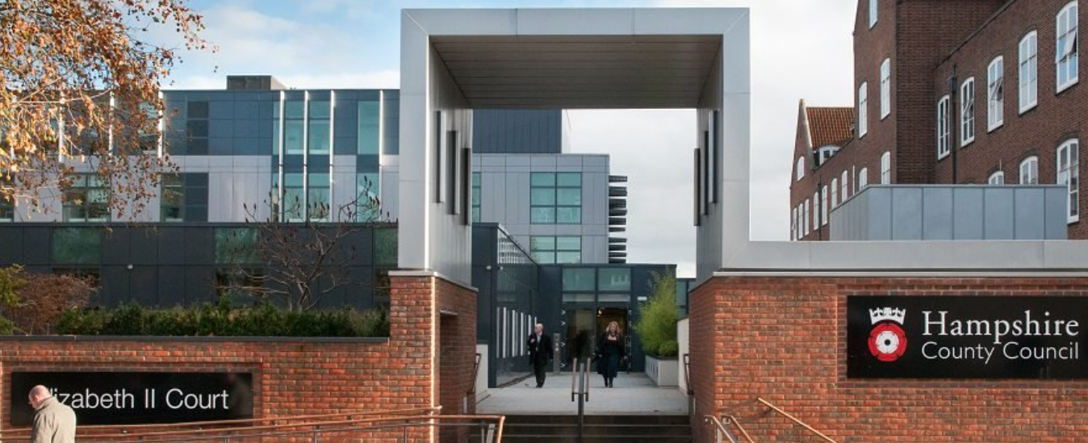

Reception:
Layout of ground floor of EII:
Toilets
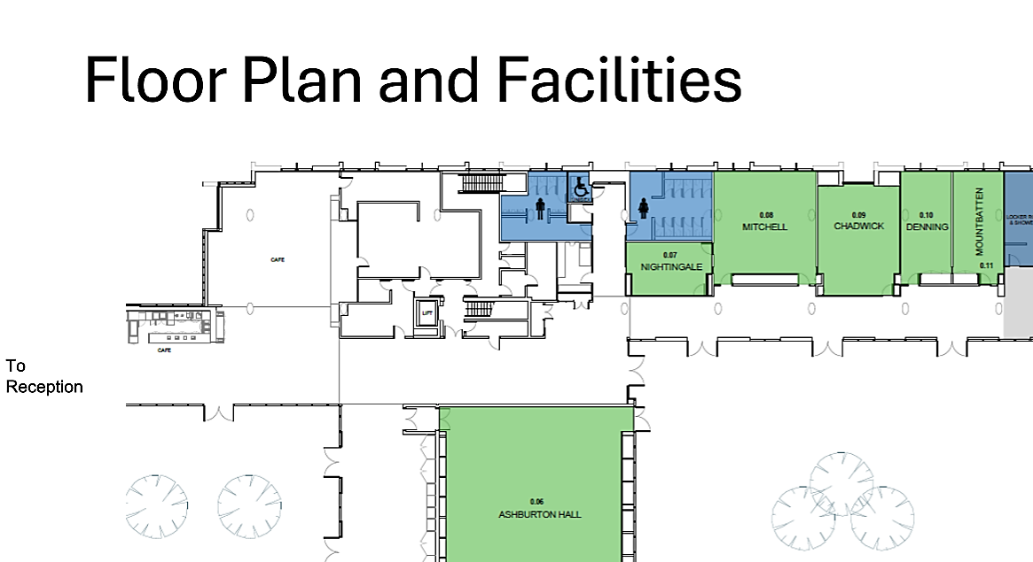
Refreshments:
There are no refreshments provided at meetings or events including no water.
There is a café and restaurant on the outside you can get hot and cold drinks and snacks/lunch (details of the opening times in pic below):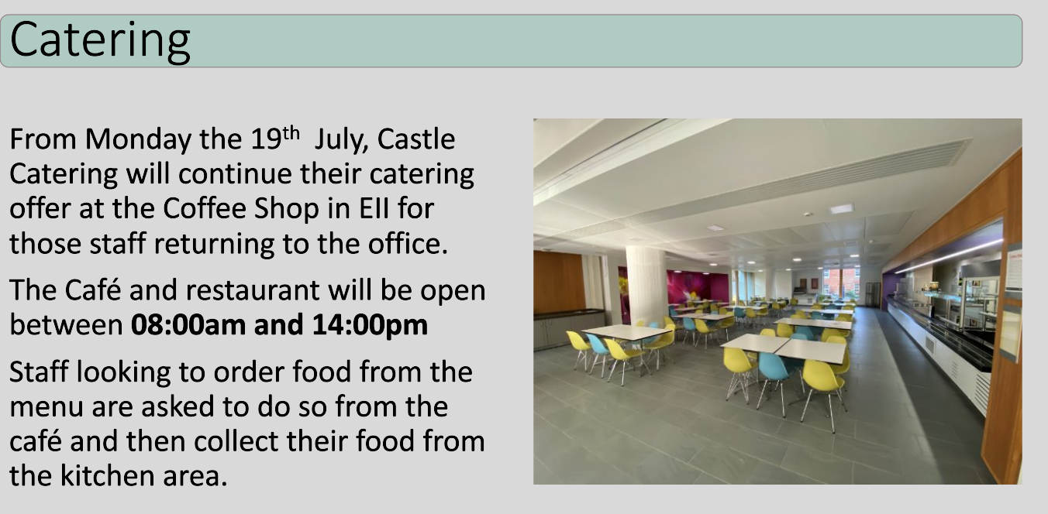
Café:
RECEPTION

Fire Alarms and Procedures:

Important - Please make staff aware if you may not be able to reach a place of safety unaided in the event of a fire alarm sounding.

The fire alarms are tested every week:
- Elizabeth II Court South: Monday at 9:30am
- Elizabeth II Court North, East and West: Tuesday at 10:00am

If you hear the alarm at these times, it may be a planned test but if you are unsure, follow staff instructions.

If there is a fire alarm or someone tells you there is a fire:
- Leave the building straight away using the nearest safe fire exit.
- Do not stop or return to collect belongings.
- Go to the assembly point shown below.
- Tell the Building Warden where the fire is, if you know.
- Do not go back into the building until the emergency services say it is safe.

Evacuation Point:

The evacuation meeting point is on Castle Avenue, outside the Great Hall.
