Weight Management Toolkit Resources Feedback Form
About you
1. Which of these below best describes you?
Tick one box.
I work in a staff team
I am a family member or friend supporting someone
I use the resource(s) myself
Other

2. Which resources have you used?
Tick all the boxes that apply.
Video: 1. How to manage common conditions with learning disabilities
Document: 1 How to manage common conditions with learning disabilities
Video: 2. Management of ARFID and rigid eating rules
Document: 2 Management of ARFID and rigid eating rules
Video: 3 Prader-Willi Syndrome
Document: 4. Weight management for learning disabilities
Booklet: 5A. A healthier me
Booklet: 5B. A healthier me Prada-Willi syndrome
Document: 5C. Session Plan
Document: 5D. Carb and protein portion activity
Booklet: 6A. Healthier me activity book
Document: 6B. Certificate
Document: 7. Role modelling

3. How did you use the resource(s)?
Tick all the boxes that apply.
With one person
With a group
By myself
What did you think about the toolkit?

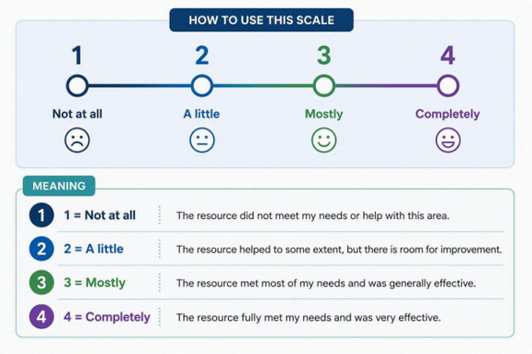
For each sentence, tick one box.

Was the toolkit useful? | 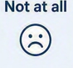  1 | 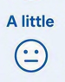  2 |   3 | 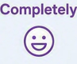  4
The information and resources were useful to me.
The toolkit helped me understand things better.
The toolkit gave me ideas or tools I can use.
I would use the toolkit again.

I would tell other people about this toolkit.
The toolkit helped me do what I needed it to do.

Was the toolkit easy to use? | 1 | 2 | 3 | 4
The toolkit was easy to use.

The toolkit was easy to follow.

The information was easy to understand.
The words were clear and easy to read.
The resources looked clear and well presented.
I could use the resources without help.

Thinking about what you have learned | 1 | 2 | 3 | 4
I feel confident to use what I learned from the toolkit.
The toolkit has changed something I do at work or in everyday life.

Please tell us about any changes you have made.

How could we make the toolkit better?

Please send your completed feedback form to PublicHealthHampshire@hants.gov.uk

Thank you for completing this feedback form.
Your feedback is important to us and will inform the continued development of our resources, helping to ensure they remain relevant, useful, and effective.

